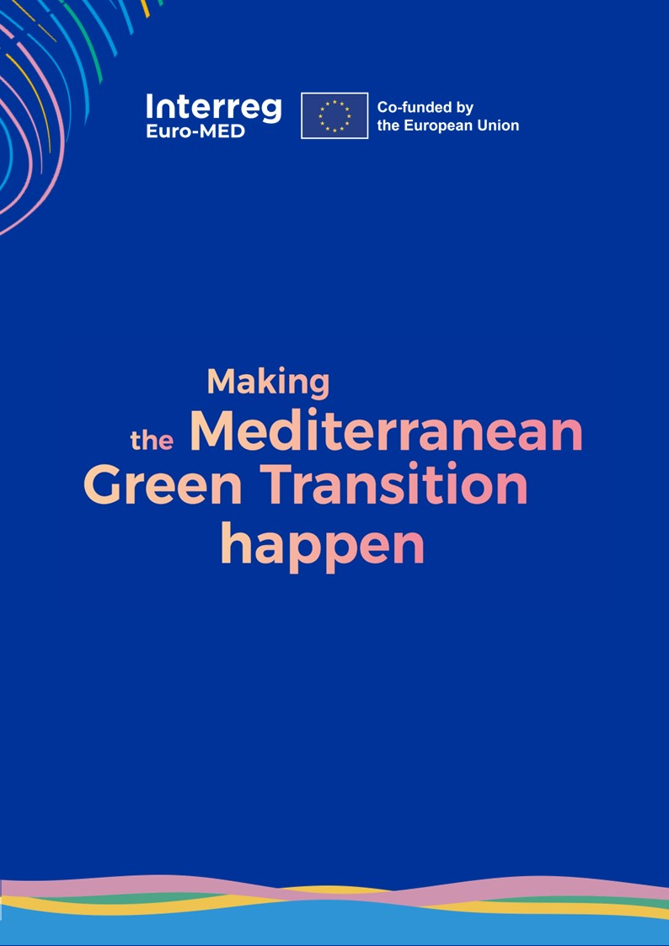




From submission to online training

This document will enable Thematic and Governance projects to provide detailed information about the proposed course/module. The Educational Committee of the Euro-MED Academy will review and assess it.

Table of Contents

Proposal Template 5
1/ TITLE (10 words max) 5
2/ Syllabus 5
3/ Presenting the education team: 6
4/ Certification 6
5/ Learners’ engagement 7
6/ Highlights of the training materials 7
7/ Module index/dashboard 7
8/ Participants’ presentation (not compulsory) 7

Proposal Template

The submission of the proposal is a two-steps process: First, submit your draft proposal by filling in the sections 1 & 2 of the following document, and send it to academy@interreg-euro-med.eu. The Educational Committee will review it and validate within 10 working days.
Following the validation of the first step, you can fill-in the full Proposal template.

1/ TITLE OF THE TRAINING (10 words max)

- NAME OF THE PROJECT:
- MISSION IT BELONGS TO: SELECT A MISSION
- CONTACT PERSON(S):
- THEMATIC LINES: Select the most relevant thematic line(s) for the course (maximum 2)
THEMATIC LINE 1 THEMATIC LINE 2

- KEYWORDS: Provide up to 5 keywords (total) in line with the course

KEYWORDS KEEP KEYWORDS PROGRAMME
KEYWORDS KEEP KEYWORDS PROGRAMME
KEYWORDS KEEP KEYWORDS PROGRAMME
KEYWORDS KEEP KEYWORDS PROGRAMME
KEYWORDS KEEP KEYWORDS PROGRAMME

2/ Syllabus
- FORMAT //400-500 characters// Describe how the module is structured in a few lines. For example, what is the minimum required engagement from the participants (in terms of time), if there are live lectures, tutoring, virtual meetups…

- WHY ATTENDING //400-500 characters// Focus on what makes this module more attractive and different from what can be found on the market (it is advisable to create a direct link with the Material available in the Library).

- WHO SHOULD ATTEND //1000-1500 characters// Build the argument to convince the most important target audience/s (no more than three, otherwise it is not credible) to participate. Please specify the relevant stakeholder of the Quadruple Helix.

- LEARNING OUTCOMES //1000-1500 characters// Be specific about what the participants will learn in attending this module. Remember that training is or should be a transformative experience, so participants should not get out of the course when they get in, but they should take something they have found in the course.

- LEARNING EXPERIENCE //1000-1500 characters// Be specific about the learning methodology: who are the lecturers/trainers (at least some hints about the profile we are looking for). If there will be live lectures, tutoring, virtual meetups, practical exercises, peer-learning opportunities, or case study presentations, please specify.

- TRAINERS: education team bios

- EVALUATION PLAN: Please specify if you have any specific assessment requests in addition to the standard ones (see section 0.4). Specify also the timeframe to complete the tests.

- Overview of course structure: Estimated list of courses, estimated duration of courses, estimated list of live conferences and meetups (if applicable)
3/ Presenting the education team:
Thumbnail picture + bionote
- Partners in charge of the module
- Trainers/lecturer
- Instructional designer
- Guest speakers
- Tutor
- Facilitator

4/ Certification
- Attendance certificate: just listen to the lectures, read materials and does the shortest knowledge check → badge of attendance obtained in each course
- Verified certificate: participate in all the lectures, optional live events (if applicable) and pass the final tests

5/ Learners’ engagement
- Provide the estimated engagement (weekly)
- Provide the estimated video lectures (weekly)
- Provide reading suggestions
- Specify the type of exercises foreseen
- Knowledge tests: specify the exam format and time allowed
  - knowledge check (multiple choice or other automatic assessment tests, after each unit, if applicable)
  - final test: 20’ minutes (multiple choice or other automatic assessment tests at the end of the course)

6/ Highlights of the training materials
- How many hours of video contributions
- how many live conferences and virtual meetups… (if applicable)

7/ Module index/dashboard
- List of all the course
- List of all the live conferences (if applicable)
- List of all the meetups (if applicable)
- Specify the duration of all the course

8/ Participants’ presentation (not compulsory)
- Every participant is invited to introduce him/herself in a forum
- Every course can choose how much participants can/should say about themselves

