Creating users account

Following reception of this form, users account can be created and this document has to be filled in and sent to academy@interreg-euro-med.eu. Remind to create the users account before sending the form.

TITLE OF THE TRAINING (10 words max)

- NAME OF THE PROJECT:
- MISSION IT BELONGS TO: SELECT A MISSION
- CONTACT PERSON(S):

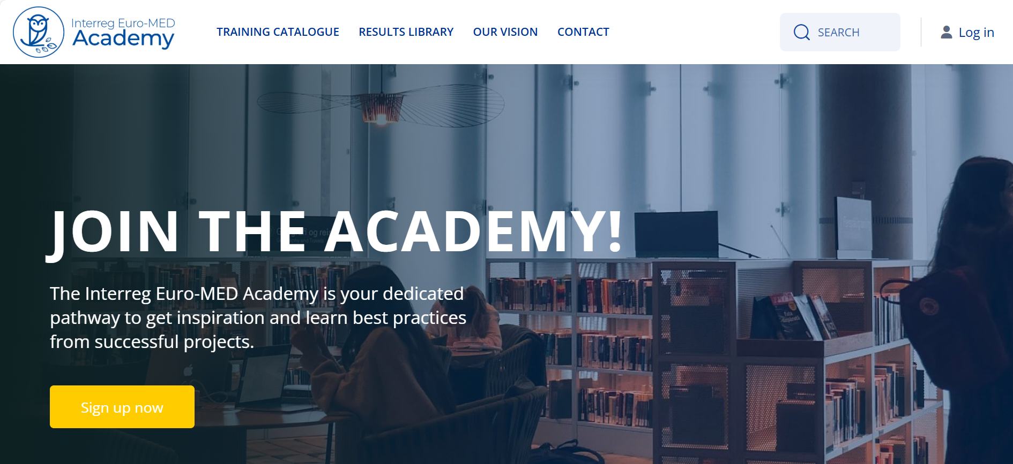

- After reception of the document, users account can be created on Home | Interreg Euro-MED Academy by clicking on the “Sign up now” button.

- Following the validation of all account users, please provide the names & surnames of all courses creators that will take part to the elaboration of contents on the platform. The number of course creators is not restricted, although we recommend keeping it as limited as possible for practical reasons.

Course creator 1:
Course creator 2:
Course creator 3:

